**Engineering Notebook**

**Team 16 – Clear Path**

**09/12/2024** - Team 16s first meeting and talk with customer, Dr. Towhidnejad. Scrumwise and Github established to start adding to backlog and documentation for the project. Division of skills between team members like Scrum-Master, Software, Hardware, and documentation. Stand up meeting to discuss the proposed objectives from customer and first steps taken.

**09/24/2024** - Teams first day in LB 131 with the flight simulator. Below is some of the information we gathered.

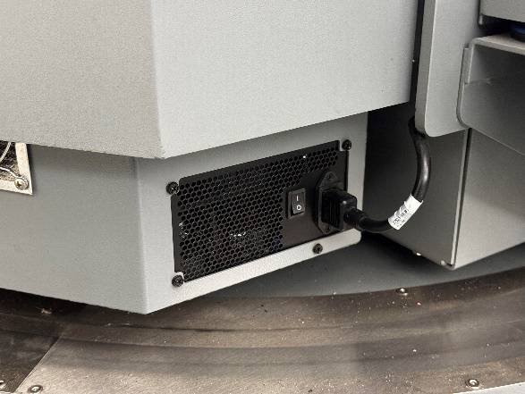

The white switch turns on the whole rig, and the smaller switch on the right side is now to turn the PC on.

There is a small red button below the seat on the right side, click the button one time for the green light to illuminate. Finally plug a wired keyboard into the hub on the right picture, follow the prompts on the screen and get to the home screen. From there we can use the wireless keyboard with mouse built in to navigate. We also uploaded any relevant text documents into our GitHub (<https://github.com/SadeedKhan555/ClearPath>).



We got some time in on the simulator to see the different function, and displays within X-Plane.

10/15/2024 - Replacing Emergency stop button, part was ordered a week in advance install was slowed due to hurricane and campus closure. Images for button install are below. In addition, the peer reviews were completed by team members along with the sprint review presentation.



10/22/2024 - United Briefing; No work done

10/24/24 – Team meeting with student previously in charge of flight sim to ask questions related to start-up and uploading/inserting data into Xplane. Installation of graphics drivers to flight sim computer to start running XPlane 12. Sprint 3 finished; Items on backlog rearranged to reflect future project progress.

* Sprint obectived accomplished:
  + Meeting with student in charge of sim

10/24/2024 - I started working on the SRS version 1. It was important for us all to collaborate on this project. However I found that I was the only if not one of the only people working on this this day. Isaac was trying to get the plug in going.

10/29/2024 -The SRS was due this day and no one had worked on it. It was incredibly rushed and we attempted just to finish it all in one day. I mentioned to the group that I tried to get started on it early and that we really should for the future. This day was set Soley on documentation.

10/31/2024 - Once we completed the SRS, he had to continue to work on the actual project. Me and Isaac were looking at ways we could import an API. We first explored FlightRadar 24, but it was not going to work as planned. We also started working on our presentation.

11/05/2024 - This was an in class presentation day so we didn't work in class. But we worked outside of class. This day was focused on presentation prep. We needed to iron out our slides and make sure everyone knew what to say and in what time to say it.

11/07/2024 -Presentations so we didn't do much

11/12/2024 - This day was focused more on trying to get the implementation of the API info the simulator

11/14/2024 - We continued to work on getting the implantation in. We also started work on the SDD this time. I was able ot get a couple people to work on it so we could avoid a situation like the SRS.

11/19/2024 - Me and Michael started to work on what the poster would look like. We had a couple of renditions and were bouncing around ideas for things.

11/21/2024 -Me and Michael completed the poster, and we were very satisfied with how it looked.

11/26/2024 - This is right around the time for break and our SRS v2 is due soon. I did not get any help on this at first. I was working on most of the sections this day

11/28/2024 - This is on thanksgiving and I completed my part of the SRS. I felt like I did most of it and even started on the test plan this day. Bearing in mind this was all over break.

12/03/2024 - This day we recorded and I edited and submitted the video. I had everyone do their part and recorded myself doing a voice over in the simulated environment. I need to gt the poster from undergraduate research.

12/05/2024 - This is our poster presentation day, I also have to return the poster i borrowed from undergraduate research.

1/9/2025 - First day of classes, we went over expectations and things to address for this semester.

1/14/2025 - Completed research into xplane plug ins. I started programming a plug in but have run into a lot of trouble. We as a team came up with a way to spawn in static objects into the simulated environment as well.

1/16/2025 - Continued research and started coding a plug in. We also looked for already created plug in templates online.

1/21/2025 - We went through the SRS and verified all the requirements we wanted were put into the document. We also went through and added appendix F, personal notes and project impacts.

1/23/2025 - We completed the justification for the items we took out and added to in the SRS, we showed it to our TA, and he will try to get back to us on Tuesday with his list of changes and look over our justification.

1/28/2025 - We took Raj’s log of changes and our log and wrote up complete justification statements to back up the changes we made. We are then going to show him these changes so he can get back to us with any other things we need to fix before submitting.

1/30/2025 - Fixed comments from SRS V2. Me and Michael fixed the diagrams that Raj brought to our attention and created the class model diagram. There was about 19 comments, I did roughly 13, and cannon took care of the rest. Most of the items in the comments just needed to be updated.

2/4/2025 - I started looking into creating the incursion plug in for fly with lua. This way I was thinking we could run this from the code runner within xplane.

2/6/2025 - I started developing lua code to try to make it run, I am trying to build the script first. I will finish the script today.

2/11/2025 - I finished the code and when implementing it I ran into issues with the SDK not working so I could not spawn an object in with the “XPLM” command I will begin to explore the route of creating an actual plug in from scratch to do this we may have to do it through visual studio 2022.

2/13/2025 - I tried implementing the visual studio project but again had issues with the header files not being recognized correctly. I think this issue sprouts from the packages not being read. I’m unsure where to go form here

2/18/2025 - Me and Michael went into the sim today and again tried to run the visual studio file but it was not able to get it to run. We are going to try isaac’s implementation via python. In the meantime, I can use this time to work on the SDD.

2/20/2025 - We are working to at least get the static object to spawn the way we want as a runway incursion. This is where we are going to have to be for now. We have had a ton of trouble the last couple weeks getting any other implementation to work.

**02/22/2025** – Started researching potential methods for integrating live weather data into the X-Plane simulation environment.

**02/25/2025** – Continued research into weather integration plugins and APIs. Reviewed compatibility with existing simulator setup.

**02/28/2025** – Successfully integrated live weather into the sim. Initial tests showed somewhat accurate real-time conditions.

**03/03/2025** – Adjusted plug in to simulate varied scenarios. Confirmed sync between plugin and simulated environment.

**03/06/2025** – Began exploring options for ATC integration, some included audio feeds and or maybe a simulated ATC.

**03/10/2025** – Integrated ATC into the simulation environment using available data feeds. But they did not match up with the phases of flight we were in.

**03/13/2025** – Able to integrate simple ATC, updates in phases of flight. We also started doing arbitrary tests on both live weather and ATC features.

**03/17/2025** – Captured footage of the new systems to for media for the final project video.

**03/21/2025** – Continued capturing sim footage with varying traffic and weather conditions for demo purposes.

**03/26/2025** – Conducted testing, from requirements in SDD and testing document. We also started updating the testing document.

**04/01/2025** – Helped on the testing document, outlining procedures and expected outcomes, started filing in testing.

**04/08/2025** – we started developing the final presentation. We also started recording. Focusing on highlighting the new features.

**04/12/2025** – Final simulator testing completed with all systems integrated results reviewed and confirmed.

**04/15/2025** – turned in testing document, starting to work on movement and trying to make it work.

**04/17/2025** – Made the final presentation and recorded the project video showcasing the integrated simulator features.

04/22/2025 - Ensured the sim was properly working and finished peer evaluations. I also checked with Canon to make sure he was all good with the video. I finished editing the speech portion all he needs to do is add the demo video.

4/24/2025 - Poster presentation day. This is the final day of class.